Section 4: Security And Ergonomic Settings (Member 4 - Bich Phuong)

Introduction
This section presents a detailed explanation of the implementation of security measures, ethical considerations, and digital health practices within the Digital Team Hub project. Beyond simply describing the applied methods, this section aims to highlight their importance in ensuring a safe, responsible, and efficient collaborative environment for all team members.
In the context of modern digital collaboration, teams often rely heavily on online platforms such as cloud storage systems, version control tools, and communication applications. While these technologies increase productivity and convenience, they also introduce potential risks related to data breaches, unauthorized access, and misuse of information. Therefore, implementing robust security measures is essential to protect both individual and team data.
In addition to security, ethical considerations play a vital role in maintaining trust and accountability. The use of digital tools, particularly Artificial Intelligence (AI), must be conducted responsibly, ensuring that outputs are accurate, transparent, and do not violate academic integrity or intellectual property rights.
Furthermore, digital health—especially ergonomics—is an increasingly important aspect of working in technology-based environments. Prolonged screen time and improper workstation setups can negatively impact physical health, leading to issues such as eye strain, musculoskeletal disorders, and decreased productivity.
By integrating these three pillars—security, ethics, and digital health—the Digital Team Hub project aims to create a balanced environment where team members can collaborate effectively while maintaining both safety and well-being.

2. Security Implementation

2.1 Two-Factor Authentication (2FA) Setup
Objective: The objective of implementing Two-Factor Authentication (2FA) is to significantly enhance account security by requiring users to verify their identity using two independent factors. Typically, this includes something the user knows (password) and something the user has (a mobile device or authentication app).
This additional layer of protection is particularly important in team-based projects where multiple users access shared platforms. Even if a password is compromised through phishing or weak security practices, unauthorized access can still be prevented through 2FA.
Steps:
Navigate to the account security settings of the platform (e.g., GitHub, Google).
Select the option to enable Two-Factor Authentication.
Choose an authentication method (commonly an authenticator app).
Scan the QR code provided by the platform using an authentication application such as Google Authenticator or Microsoft Authenticator.
Enter the time-based verification code generated by the app to confirm activation.
Save backup codes in a secure location in case the authentication device is lost.
Result: All team members successfully enabled 2FA across essential platforms. This ensures that all shared resources, including project repositories, documents, and communication channels, are protected against unauthorized access.
Extended Impact:
Reduces risk of cyberattacks such as credential stuffing and phishing.
Promotes awareness of cybersecurity best practices.
Encourages accountability among team members when accessing shared systems.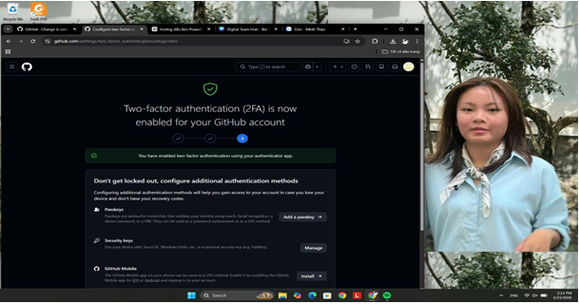
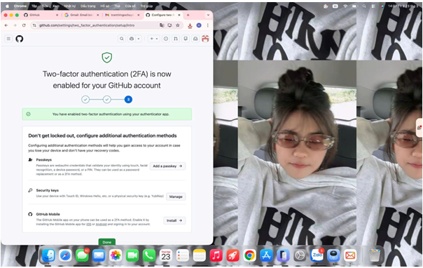
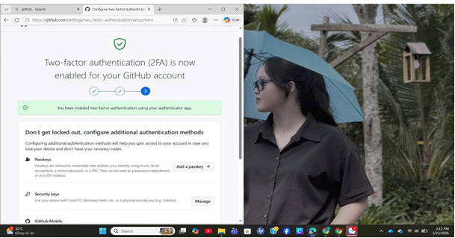
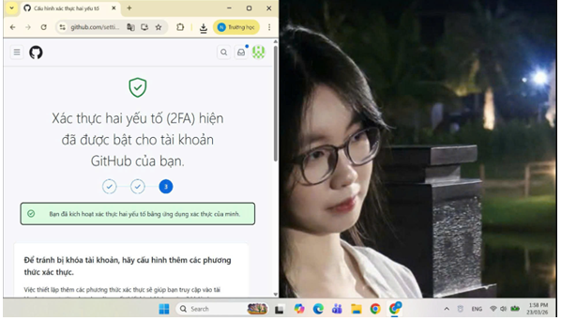

2.2 Team Password Policy
Objective: The purpose of establishing a password policy is to create a standardized approach to password creation and management, thereby minimizing vulnerabilities caused by weak or reused passwords.
Policy Rules:
- Password length must be between 8–12 characters (or longer when possible for increased security).
- Passwords must include: Uppercase letters, lowercase letters, numbers, special characters (e.g., @, #, $, %).
- Password reuse is strictly prohibited.
- Passwords must be updated every 60–90 days.
- Avoid using personal information such as names or birthdays.
- Use passphrases instead of simple passwords for better memorability and strength.
- Utilize password managers (e.g., LastPass, Bitwarden) to securely store credentials.
- Enable alerts for suspicious login activity.
Result and Benefits: The implementation of this policy ensures that all team members follow consistent security practices. It reduces the likelihood of password-related breaches and strengthens the overall security infrastructure of the project.

Ergonomics (Digital Health)
Digital health focuses on maintaining both physical and mental well-being while interacting with digital technologies. Ergonomics, a key component of digital health, involves designing and arranging workspaces to fit the user’s needs, thereby improving comfort, efficiency, and safety.
Poor ergonomic practices can lead to various health issues, including:
- Neck and shoulder pain
- Lower back problems
- Eye strain and headaches
- Repetitive strain injuries (RSI)
Key Ergonomic Factors:
Monitor Position: The top of the screen should be at or slightly below eye level.
Posture: Back should remain straight with proper lumbar support.
Viewing Distance: Maintain a distance of 50–70 cm from the screen.
Lighting: Ensure sufficient lighting to reduce glare and eye fatigue.
Breaks: Follow the 20-20-20 rule (every 20 minutes, look at something 20 feet away for 20 seconds).
Each member provided images of their workspace:
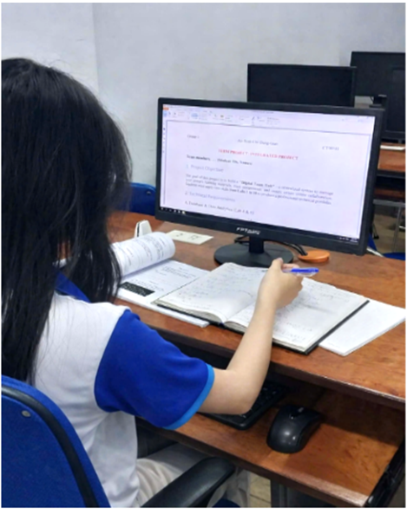

Member 1: Tuong Vy
Observation: The member is using a desktop monitor placed slightly below eye level. The sitting posture shows a slight forward lean while writing notes.
Issues Identified: Neck bending downward may cause strain; writing posture not fully supported.
Improvements Suggested: Raise monitor height to eye level and maintain a straight back posture while working.
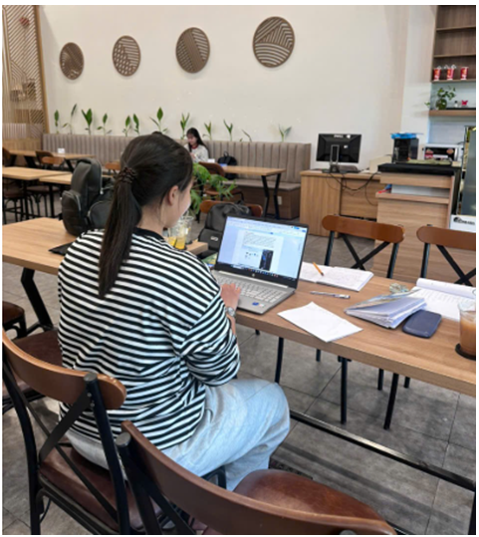
Member 2: Ngoc Huyen
Observation: The member is working on a laptop in a café-like environment with moderate lighting. Posture is relatively upright but slightly hunched forward.
Issues Identified: Laptop screen too low leading to neck strain; prolonged sitting without back support.
Improvements Suggested: Use a laptop stand and external keyboard; ensure back support while sitting.

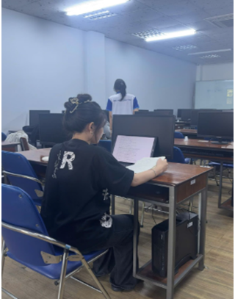
Member 3: Nhu Y
Observation: The member is seated in a computer lab using a laptop placed on a desk. Posture is slightly leaned forward with arms resting on the desk.
Issues Identified: Screen height is low; chair does not fully support ergonomic posture.
Improvements Suggested: Adjust chair height and keep screen closer to eye level; maintain neutral wrist position.
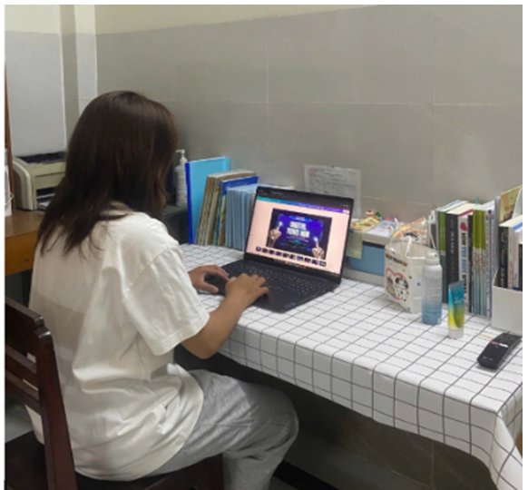
Member 4: Minh Thao
Observation: The member is working at a home desk setup with a laptop. The desk is organized with books and personal items; posture is slightly bent forward.
Issues Identified: Screen too low; potential eye strain due to close distance; clutter may reduce workspace efficiency.
Improvements Suggested: Raise laptop using a stand, maintain proper viewing distance (50–70 cm), and keep workspace more organized.
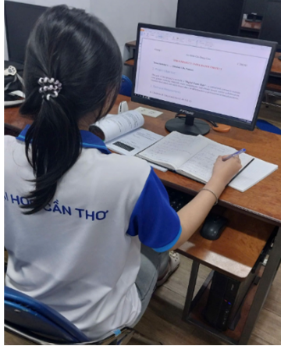
Member 5: Bich Phuong
Observation: The member is working at fixed computer desks with separate monitors; their study area contains books and printed materials; they are sitting with a slightly hunched back and head bowed while writing.
Issues Identified: Neck bent too low when looking at the notebook; back not supported by the chair causing spinal strain; edge of the desk resting on the forearm hindering blood circulation.
Improvements Suggested: Use a tilting notebook stand; sit closer to the chair to utilize the backrest; raise the monitor to eye level and use wrist rests.

4. AI Prompts
Prompt 1: "Suggest a database schema for a team management system including tables for members and assignments with primary and foreign keys."
Prompt 2: "Generate an SQL query to join the 'MEMBERS' and 'ASSIGNMENTS' tables to display full names and their task status."
Prompt 3: "Guide on using VLOOKUP and Conditional Formatting to track project deadlines in Excel."
Prompt 4: "Define Digital Health and Ergonomics principles for IT students working long hours on computers."

4.1 Ethical Use of AI:
- All AI-generated content was reviewed for accuracy
- Outputs were verified against reliable sources
- Proper acknowledgment was maintained to avoid plagiarism
- AI was used as a support tool, not a replacement for human critical thinking

4.2 Benefits of AI Integration
- Saves time in technical tasks
- Enhances understanding of complex concepts
- Supports collaborative problem-solving

5. Conclusion
In conclusion, the integration of security measures, ethical practices, and digital health principles is essential for the success of the Digital Team Hub project. The implementation of 2FA and strict password policies significantly strengthens data protection and minimizes cybersecurity risks.
At the same time, the responsible use of AI ensures that technological tools are applied ethically and effectively, supporting both learning and productivity. Meanwhile, attention to ergonomics helps maintain physical well-being, reduce fatigue, and improve overall work performance.
These combined efforts create a well-balanced working environment where team members feel secure, supported, and motivated. As a result, collaboration becomes more effective, productivity increases, and the project achieves sustainable long-term success.

